**A PROJECT ON**

**Online Electronic Shopping**

SUBMITTED IN

PARTIAL FULFILLMENT OF THE REQUIREMENT

FOR THE COURSE OF DIPLOMA IN ADVANCED COMPUTING FROM CDAC



**SUNBEAM INSTITUTE OF INFORMATION TECHNOLOGY**

Hinjawadi

**SUBMITTED BY:**

Ayush Kumar Sakure

Apurva Zurmure

Anamika Jaiswal

Shantanu Badmore

**UNDER THE GUIDANCE OF:**

Digvijay Bhunje

Faculty Member

Sunbeam Institute of Information Technology, Pune

**ACKNOWLEDGEMENT**

A project usually falls short of its expectation unless aided and guided by the right persons at the right time. We avail this opportunity to express our deep sense of gratitude towards Mr. Nitin Kudale (Center Coordinator, SIIT, Pune) and Mr. Yogesh Kolhe (Course Coordinator, SIIT ,Pune) .

We are deeply indebted and grateful to them for their guidance, encouragement and deep concern for our project. Without their critical evaluation and suggestions at every stage of the project, this project could never have reached its present form. Last but not the least we thank the entire faculty and the staff members of Sunbeam Institute of Information Technology, Pune for their support.

Ayush Kumar Sakure, Apurva Zurmure, Anamika Jaiswal, Shantanu Badmore

eDAC MAY 2021 Batch,

SIIT Pune

**CERTIFICATE**

**This is to certify that the project work under the title ‘Online Electronic Shopping’ is done by Ayush Kumar Sakure, Apurva Zurmure, Anamika Jaiswal, Shantanu Badmore in partial fulfillment of the requirement for award of Diploma in Advanced Computing Course.**

**Mr. Yogesh Kolhe**

**Course Co-ordinator**

**Project Guide**

**Date:**

1. **INTRODUCTION TO PROJECT**

**Abstract:**

Online electronic shop is a project developed to make the purchase of electronics easy. This application makes the need of the sales and purchase of electronics safe. This application will reduce the manual operation required to maintain all the records of sales and purchase. This system allows to search number of  stocks details of electronic items. Different types of electronic items will be available to the users in this application.

**Existing System:**

The existing system requires more time for processing.  The process is very slow and lengthy. Not any type of security is provide so it may lost data or product. Difficult in searching the pervious data. More men power is required. It requires lots of time to travel to the particular shop to buy the goods. It is having lots of manual work.  It is less user-friendly. User must go to shop and order products. It is difficult to identify the required product.

**Proposed System:**

The proposed system consist of the registration module for the customer & vendor. The registered customer gets the accessibility and to purchase and buy the any type of electronics products. The fixed charge on each product that has been charged by the admin as commission which is charged after the product sold. The admin has priviliges to grant access to vendor using which they can add product in the portal.

INDEX

|  |  |  |
| --- | --- | --- |
| Sr. No. | Topics | Page No. |
| 1 | Acknowledgement | 2 |
| 2 | Certificate | 3 |
| 3 | Index | 4 |
| 4 | Introduction | 5 |
| 5 | Requirements | 6 |
| 6 | Design | 10 |
| 7 | Coding Standards | 14 |
| 8 | Test Reports | 16 |
| 9 | Project management related Statistics | 19 |
| 10 | Entity Relationship Diagram | 21 |
| 11 | Class Diagram | 22 |
| 12 | Project UI | 23 |
| 13 | References | 39 |

**2.REQUIREMENTS**

**2.1 FUNCTIONAL REQUIREMENTS**

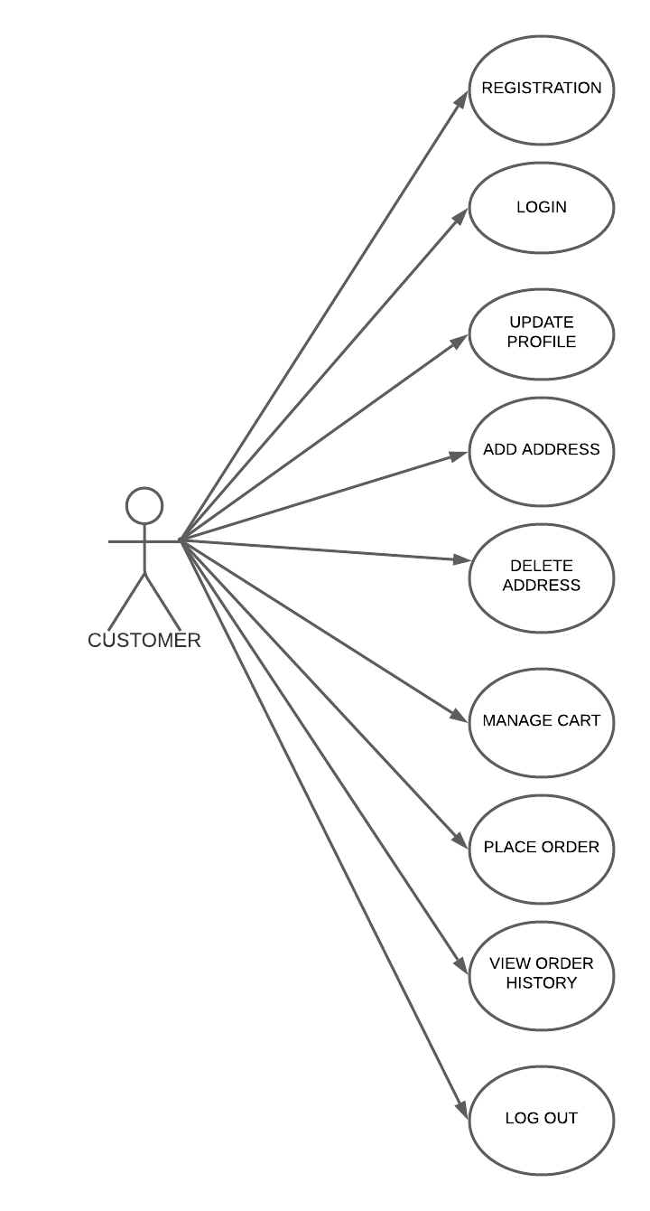

**2.1 Customer:**

Customer need to enter the personal details in the registration page. Customer can get login by entering the valid username and password. Customer can access all the products available in the application. Customer can see the order history. Customer can set the delivery address.

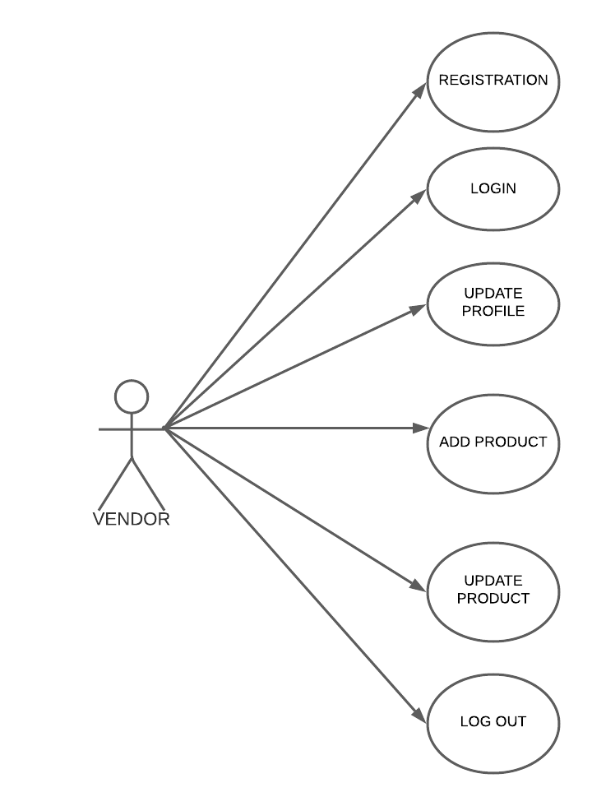

**2.2 Vendor:**

Vendor need to enter the personal details in the registration page. Vendor can get login by entering the valid username and password. Vendor needs to be approved by the admin before selling products on portal.

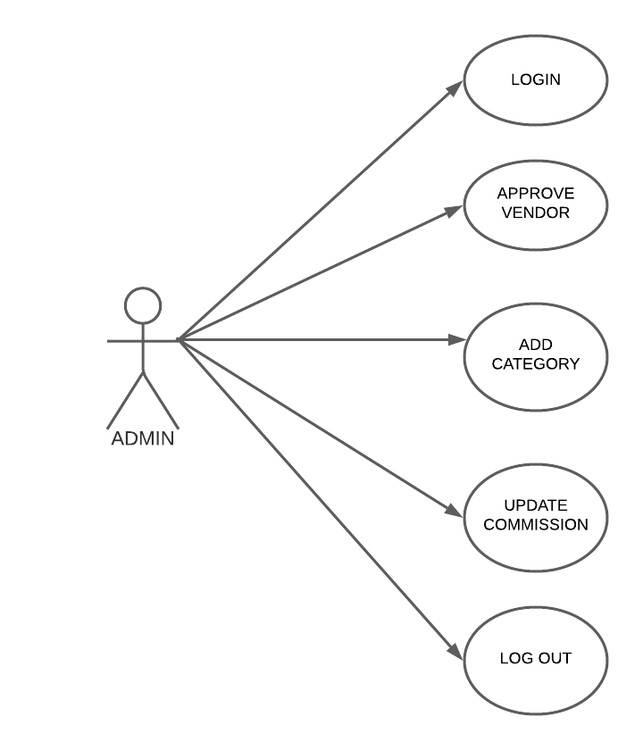

**2.3 Admin:**

Admin has been provided a secret username and password by the developer using which he can conduct the entire portal. Here admin has the authority to add new category. He can add commission to the category. Without his consent no vendor can sell the product on the portal.

* 1. **NON FUNCTIONAL REQUIREMENTS**

**2.2.1 Interface**

Go to Appendix B for user interfaces

**2.2.2 Performance**

* **Number of Concurrent Users:**

ARS shall be able to handle at least 100 transactions/inquiries per

second

**2.2.3 Constraint**

ARS shall be able to handle at least 100 transactions/inquiries per second.

**2.2.4 Other Requirements:**

* **Hardware Interfaces**

The SPMS is expected to function on Intel PIII 900 MHz Processor equivalent or above, 128 MB RAM, 20 GB HDD.

* **Software Interfaces**

The SPMS shall work on MS Windows operating systems family (MS Windows 98, MS Windows NT Workstation, MS Windows 2000, MS Windows XP). It configures to work with Oracle database. This System works on Apache Tomcat server. It uses browser IE 5.0 & above. It uses IIS 5.0 server.

**3. DESIGN**

**3.1 Database Design**

The following table structures depict the database design.

1. **Table 1: Admin_Info**

|  |  |  |  |  |
| --- | --- | --- | --- | --- |
| **Key Type/ Constraint** | **Column Name** | **Data Type** | **Length** | **Allow Null (1=Yes;0=No)** |
| primary | adminid | Int | 4 | 0 |
|  | adminname | varchar | 255 | 0 |
|  | adminemail | varchar | 255 | 0 |
|  | adminpwd | varchar | 255 | 0 |
|  | adminmob | varchar | 255 | 0 |

**Table 2: Customer_Info**

|  |  |  |  |  |
| --- | --- | --- | --- | --- |
| **Key Type/ Constraint** | **Column Name** | **Data Type** | **Length** | **Allow Null (1=Yes;0=No)** |
| primary | cusid | Int | 4 | 0 |
|  | cusname | varchar | 255 | 0 |
|  | cusemail | varchar | 255 | 0 |
|  | cuspwd | varchar | 255 | 0 |
|  | cusmob | varchar | 255 | 0 |

**Table 3: Vendor_Info**

|  |  |  |  |  |
| --- | --- | --- | --- | --- |
| **Key Type/ Constraint** | **Column Name** | **Data Type** | **Length** | **Allow Null (1=Yes;0=No)** |
| **primary** | **venid** | **Int** | **4** | **0** |
|  | **vename** | **varchar** | **255** | **0** |
|  | **venemail** | **varchar** | **255** | **0** |
|  | **venpwd** | **varchar** | **255** | **0** |
|  | **venmob** | **varchar** | **255** | **0** |
|  | **venpan** | **varchar** | **255** | **0** |
|  | **venpincode** | **Into** | **4** | **0** |
|  | **venstatus** | **varchar** | **255** | **0** |
|  | **venstate** | **varchar** | **255** | **0** |

**Table 4: Vendor Product_Info**

|  |  |  |  |  |
| --- | --- | --- | --- | --- |
| **Key Type/ Constraint** | **Column Name** | **Data Type** | **Length** | **Allow Null (1=Yes;0=No)** |
| primary | pid | Into | 4 | 0 |
|  | prodname | varchar | 255 | 0 |
|  | vprice | Into | 4 | 0 |
|  | quantity | Into | 4 | 0 |
|  | description | varchar | 255 | 0 |
|  | image | varchar | 255 | 0 |
|  | brandname | varchar | 255 | 0 |
| foreign | cid | Into | 4 | 0 |
| foreign | venid | Into | 4 | 0 |

**Table 5: Category_Info**

|  |  |  |  |  |
| --- | --- | --- | --- | --- |
| **Key Type/ Constraint** | **Column Name** | **Data Type** | **Length** | **Allow Null (1=Yes;0=No)** |
| primary | cid | int | 4 | 0 |
|  | cname | varchar | 255 | 0 |
|  | comm | float | 4 | 0 |

**Table 6: Customer Address_Info**

|  |  |  |  |  |
| --- | --- | --- | --- | --- |
| **Key Type/ Constraint** | **Column Name** | **Data Type** | **Length** | **Allow Null (1=Yes;0=No)** |
| **primary** | **aid** | **int** | **4** | **0** |
|  | **addtype** | **varchar** | **255** | **0** |
|  | **streetno** | **varchar** | **255** | **0** |
|  | **landmark** | **varchar** | **255** | **0** |
|  | **dist** | **varchar** | **255** | **0** |
|  | **state** | **varchar** | **255** | **0** |
|  | **pincode** | **int** | **4** | **0** |
| **foreign** | **cusid** | **int** | **4** | **0** |

**Table 7: Orders**

|  |  |  |  |  |
| --- | --- | --- | --- | --- |
| **Key Type/ Constraint** | **Column Name** | **Data Type** | **Length** | **Allow Null (1=Yes;0=No)** |
| **primary** | **oid** | **int** | **4** | **0** |
|  | **odate** | **Date** | **6** | **0** |
|  | **paymentmode** | **varchar** | **255** | **0** |
|  | **totalpayment** | **float** | **4** | **0** |
| **foreign** | **aid** | **int** | **4** | **0** |

**Table 8: Orders Details**

|  |  |  |  |  |
| --- | --- | --- | --- | --- |
| **Key Type/ Constraint** | **Column Name** | **Data Type** | **Length** | **Allow Null (1=Yes;0=No)** |
| **primary** | **odid** | **int** | **4** | **0** |
|  | **oquantity** | **int** | **4** | **0** |
| **foreign** | **pid** | **int** | **4** | **0** |
| **foreign** | **oid** | **int** | **4** | **0** |

**4. CODING STANDARDS IMPLEMENTED**

Below summarizes the naming recommendations for identifiers in Pascal casing is used mainly (i.e. capitalize first letter of each word) with camel casing (capitalize each word except for the first one) being used in certain circumstances.

|  |  |  |  |
| --- | --- | --- | --- |
| **Identifier** | **Case** | **Examples** | **Additional Notes** |
| Class | Pascal | Person, BankVault, SMSMessage, Dept | Class names should be based on "objects" or "real things" and should generally be **nouns**. No ‘_’ signs allowed. Do not use type prefixes like ‘C’ for class. |
| Method | Camel | getDetails, updateStore | Methods should use **verbs** or verb phrases. |
| Parameter | Camel | personName, bankCode | Use descriptive parameter names. Parameter names should be descriptive enough that the name of the parameter and its type can be used to determine its meaning in most scenarios. |
| Interface | Pascal with "I" prefix | Disposable | Do not use the ‘_’ sign |
| Property | Pascal | ForeColor, BackColor | Use a noun or noun phrase to name properties. |

* + 1. **Comments**
* Comment each type, each non-public type member, and each region declaration.
* Use end-line comments only on variable declaration lines. End-line comments are comments that follow code on a single line.
* Separate comments from comment delimiters (apostrophe) or // with one space.
* Begin the comment text with an uppercase letter.
* End the comment with a period.
* Explain the code; do not repeat it.

**5. TEST REPORT**

**Another group called Linux did the testing and the report of the testing is given hereunder.**

**GENERAL TESTING:**

|  |  |  |  |  |
| --- | --- | --- | --- | --- |
| **SR-NO** | **TEST CASE** | **EXPECTED RESULT** | **ACTUAL RESULT** | **ERROR MESSAGE** |
| 1 | Admin login Page | Pop-up will come  & redirect to next page | OK | Nothing |
| 2 | View vendor | It shows you all vendor details | Ok | Nothing |
| 3 | View customer | It shows you all vendor details | Ok | Nothing |
| 4 | View product | It shows you all product details | Ok | Nothing |
| 5 | View category | It shows you all category | Ok | Nothing |
| 6 | Add category | Add new category | Ok | Select category!!  Select commission!! |
| 7 | Update category | Update commission | Ok | Enter commission!! |
| 8 | View orders | It shows all orders details | Ok | Nothing |
| 9 | Logout | It will logout | Ok | Nothing |

|  |  |  |  |  |
| --- | --- | --- | --- | --- |
| **SR-NO** | **TEST CASE** | **EXPECTED RESULT** | **ACTUAL RESULT** | **ERROR MESSAGE** |
| **1** | **Customer login Page** | **Pop-up will come**  **& redirect to next page** | **OK** | **Nothing** |
| **2** | **View product** | **It shows you all product details with updated price** | **Ok** | **Nothing** |
| **3** | **View orders** | **It shows orders history** | **Ok** | **Nothing** |
| **4** | **View addresses** | **It shows you address details** | **Ok** | **Nothing** |
| **5** | **Add address** | **Add new address** | **Ok** | **Nothing** |
| **6** | **Delete address** | **Delete address** | **Ok** | **Nothing** |
| **7** | **Manage cart** | **Update cart** | **Ok** | **Nothing** |
| **8** | **Update Profile** | **Reset mobile no. & password** | **Ok** | **Enter Mobile no & password** |
| **9** | **Logout** | **It will logout** | **Ok** | **Nothing** |

|  |  |  |  |  |
| --- | --- | --- | --- | --- |
| **SR-NO** | **TEST CASE** | **EXPECTED RESULT** | **ACTUAL RESULT** | **ERROR MESSAGE** |
| **1** | **Vendor login Page** | **Pop-up will come**  **& redirect to next page** | **OK** | **Nothing** |
| **2** | **View product** | **It shows you all product details** | **Ok** | **Nothing** |
| **3** | **Add product** | **Add product details** | **Ok** | **Nothing** |
| **4** | **Update product** | **Set product quantity & price** | **Ok** | **Nothing** |
| **5** | **Update profile** | **Set mobile & password** | **Ok** | **Nothing** |
| **6** | **Logout** | **It will logout** | **Ok** | **Nothing** |

**6. PROJECT MANAGEMENT RELATED STATISTICS**

|  |  |  |  |
| --- | --- | --- | --- |
| **DATE** | **WORK PERFORMED** | 1. ***SLC Phase*** | **Additional Notes** |
| May 24,2021 | Project Allotment and User Requirements Gathering | Feasibility Study | Our team met the client Mr. Nitinkudale (CEO, SIIT Pune) to know his requirements. |
| May26,2021 | Initial SRS Document Validation  And Team Structure Decided | Requirement Analysis  (Elicitation) | The initial SRS was presented to the client to understand his requirements better |
| May29,2021 | Designing the use-cases, Class Diagram, Collaboration Diagram, E-R Diagram and User Interfaces | Requirement Analysis &  Design Phase | Database Design completed |
| June 5,2021 | Business Logic Component design Started | Design Phase | ---------------------- |
| July 15,2021 | Coding Phase Started | Coding Phase | 70% of Class Library implemented. |
| July 24,2021 | Implementation of Web Application and Window Application Started | Coding Phase | Class Library Development going on. |
| August 1 2021 | Implementation of Web Application and Window Application Continued | Coding Phase and Unit Testing | Class Library Modified as per the need. |
| August 5, 2021 | Implementation of Web Application and Window Application Continued | Coding Phase and Unit Testing | -- |
| August 6, 2021 | After Ensuring Proper Functioning the Required Validations were Implemented | Coding Phase and Unit Testing | Module Integration was done by the Project Manager |
| August 7, 2021 | The Project was Tested by the respective Team Leaders and the Project Manager | Testing Phase (Module Testing) | -- |
| August 28-29, 2021 | The Errors Found were Removed | Debugging | The Project was complete for submission |
| Sept 24, 2021 | Final Submission of Project |  |  |

**Appendix A**

Entity Relationship Diagram

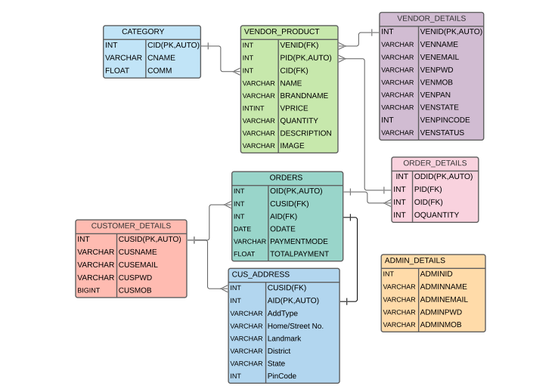

**Data Flow Diagram**

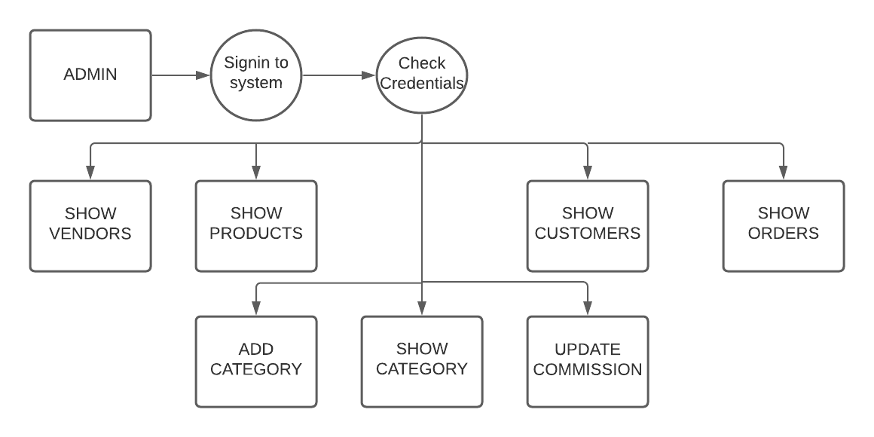

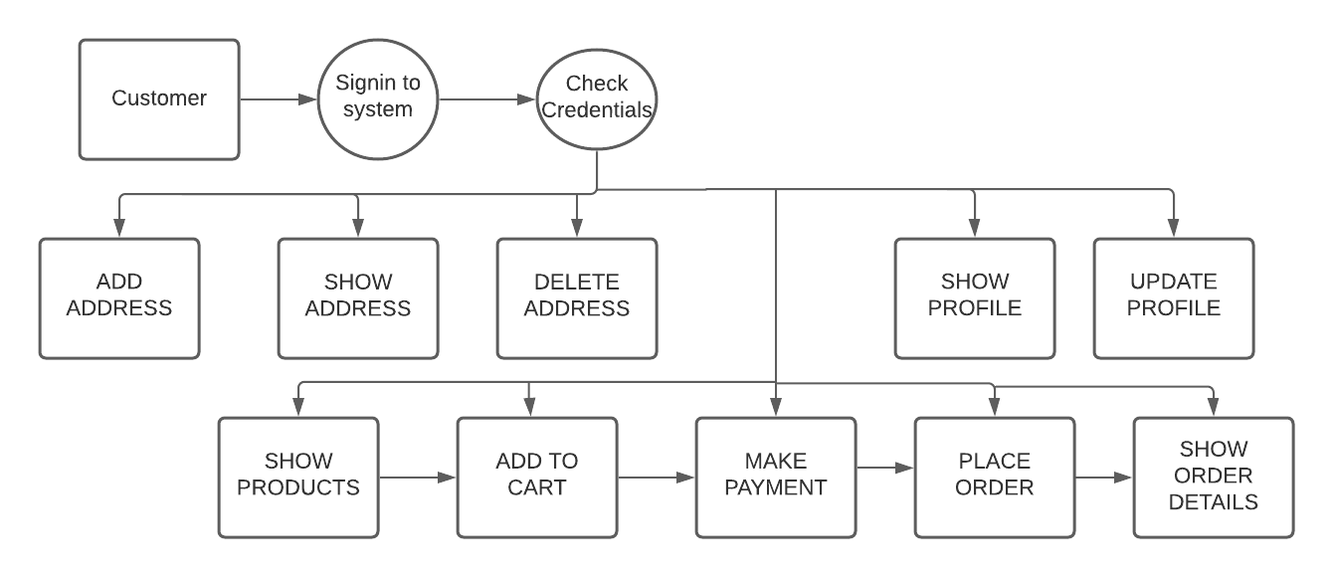

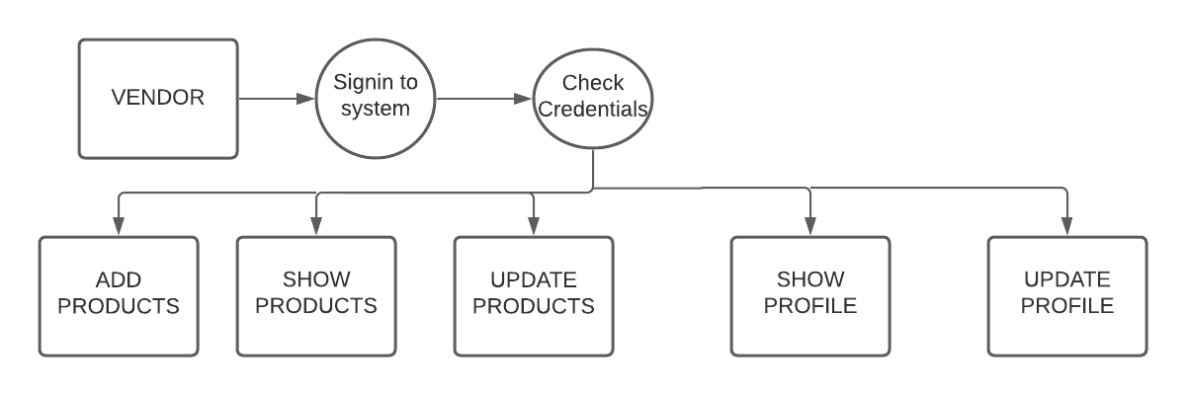

**Class Diagram**

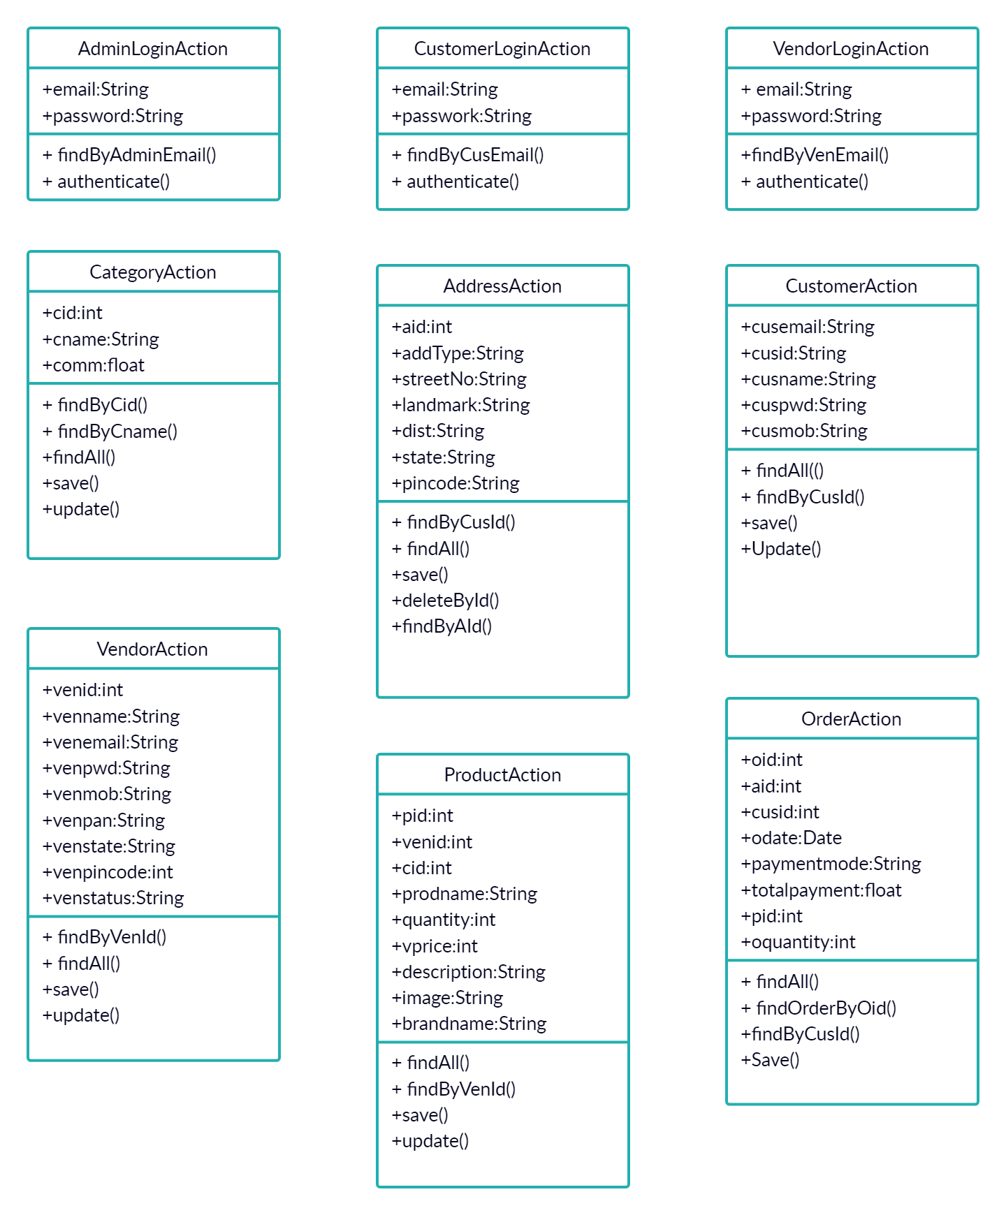

**Appendix B**

**Admin Signin:**

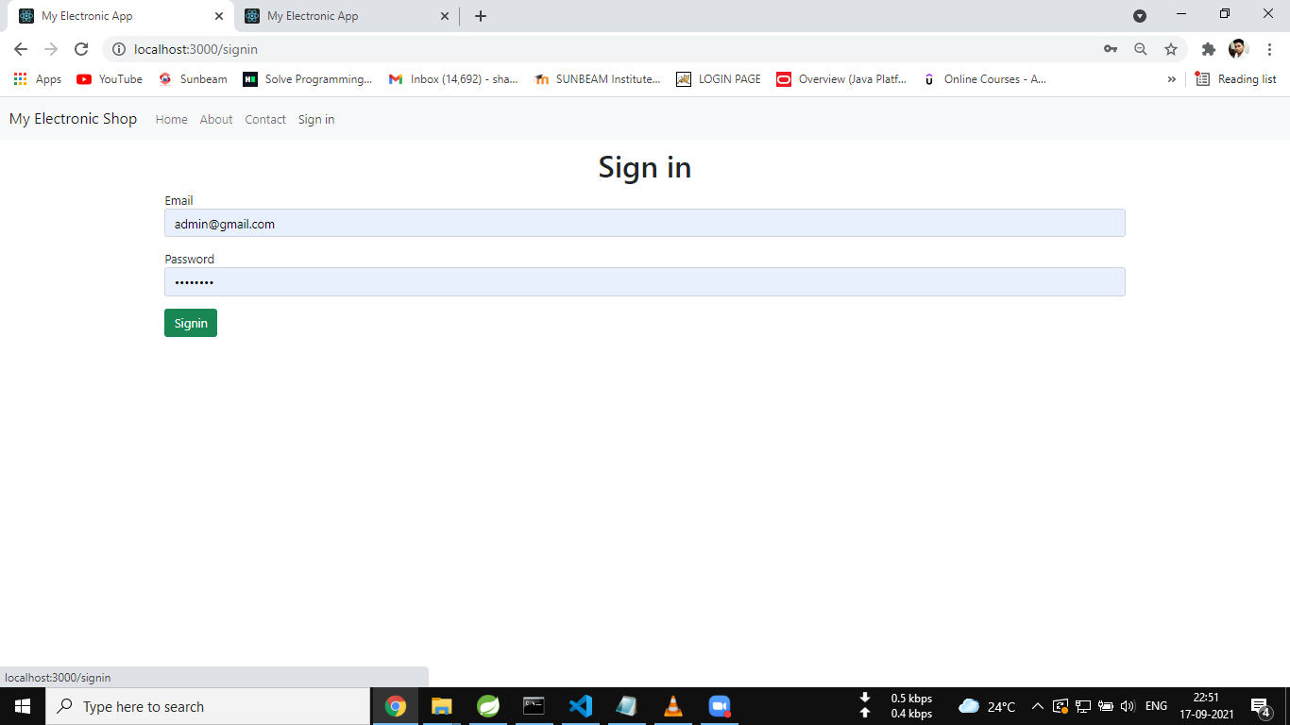

**ADMIN HOMEPAGE:**

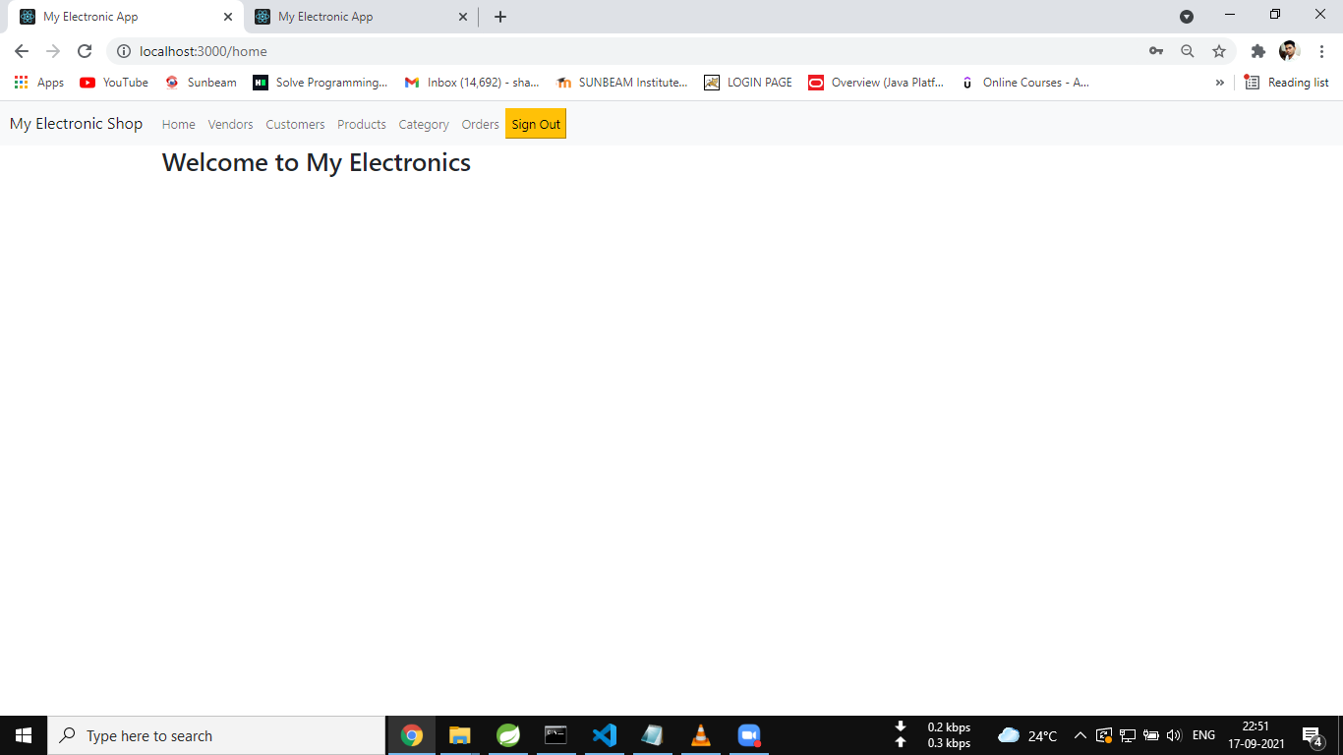

**ALL VENDORS :**

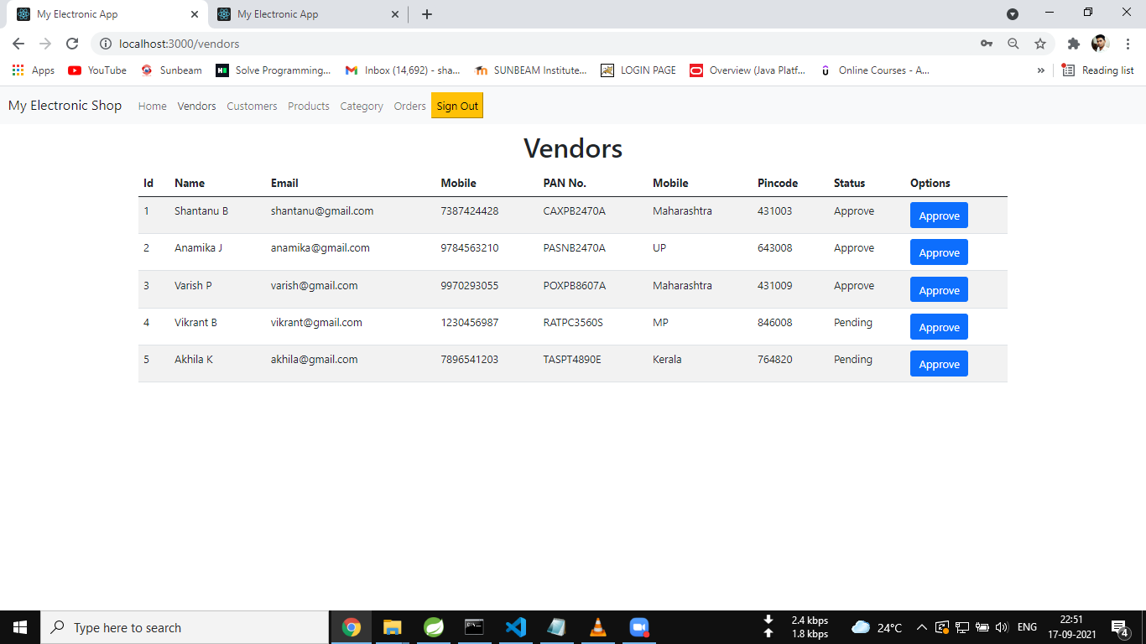

**ALL CUSTOMERS:**

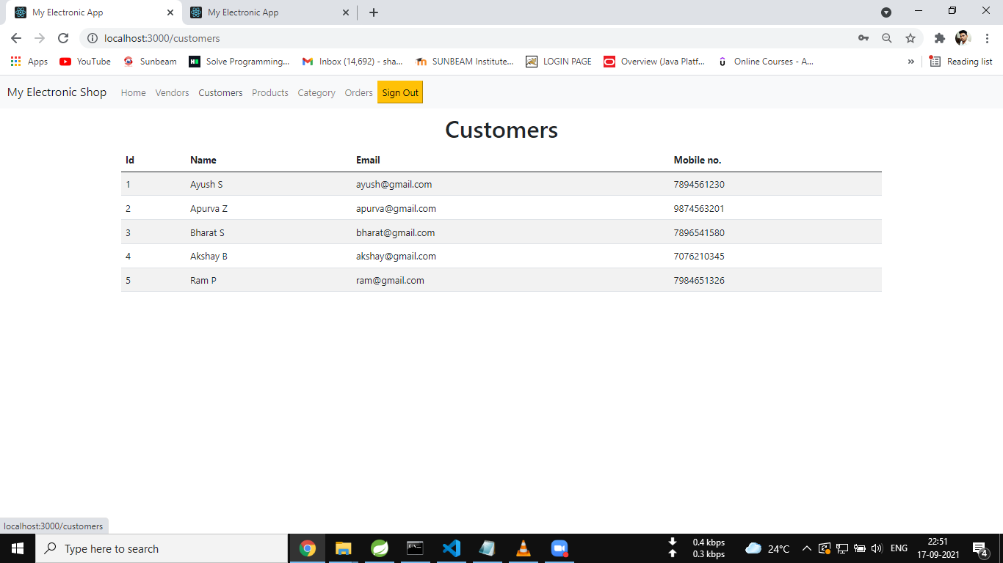

**ALL PRODUCTS :**

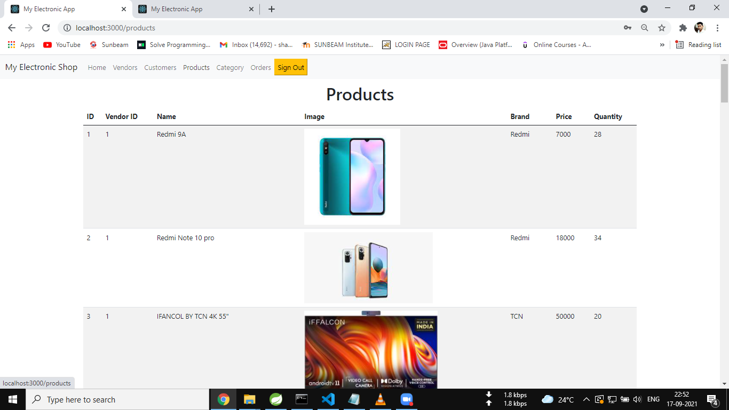

**ALL CATEGORIES:**

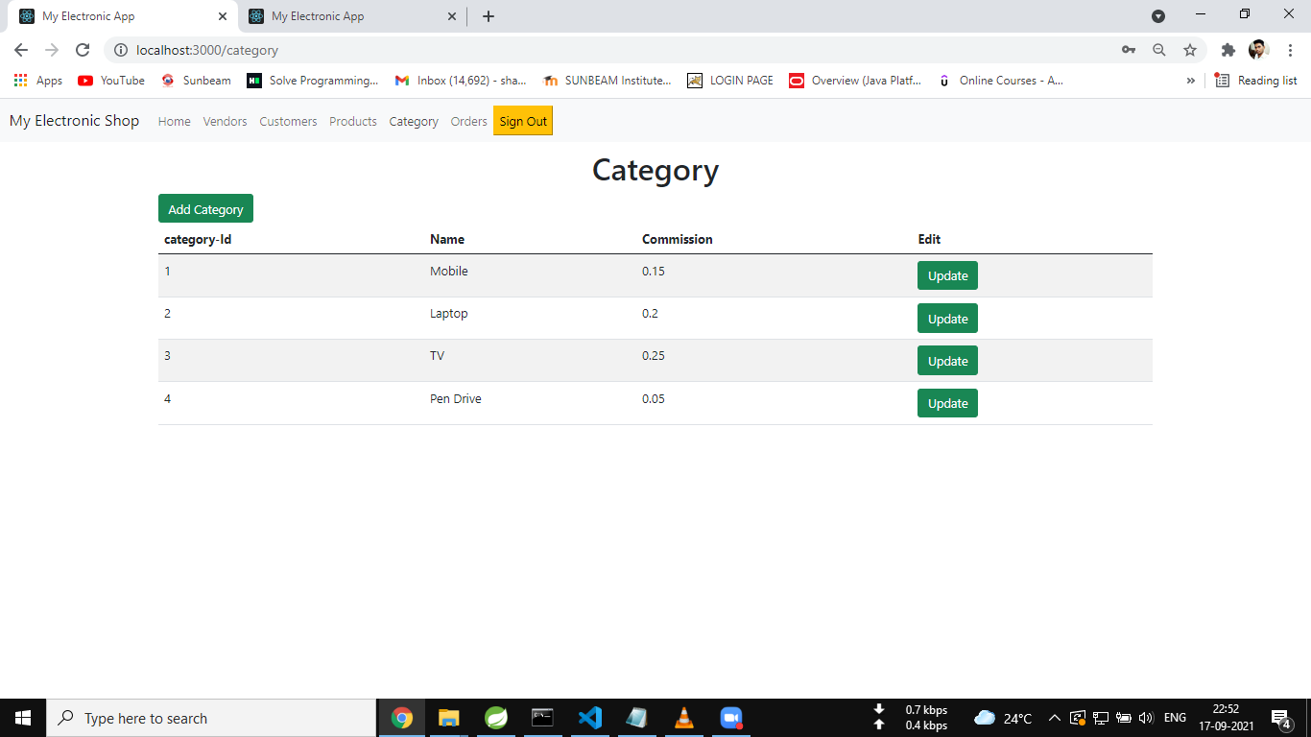

**ADD CATEGORY:**

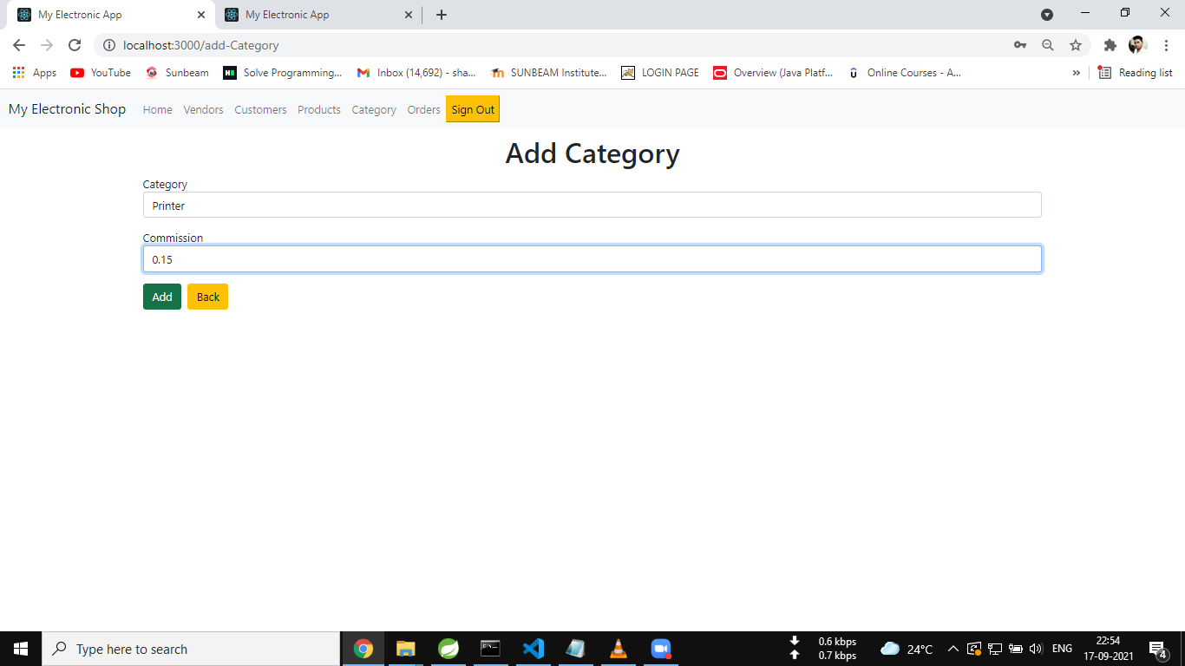

**UPDATE CATEGORY:**

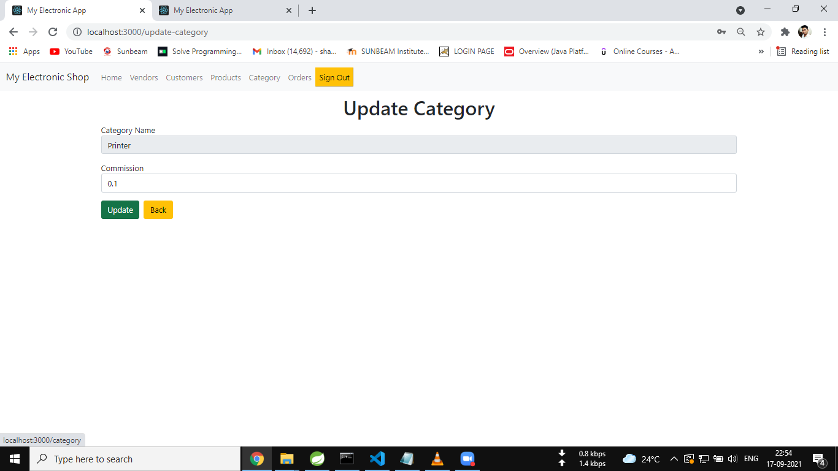

**ALL ORDERS:**

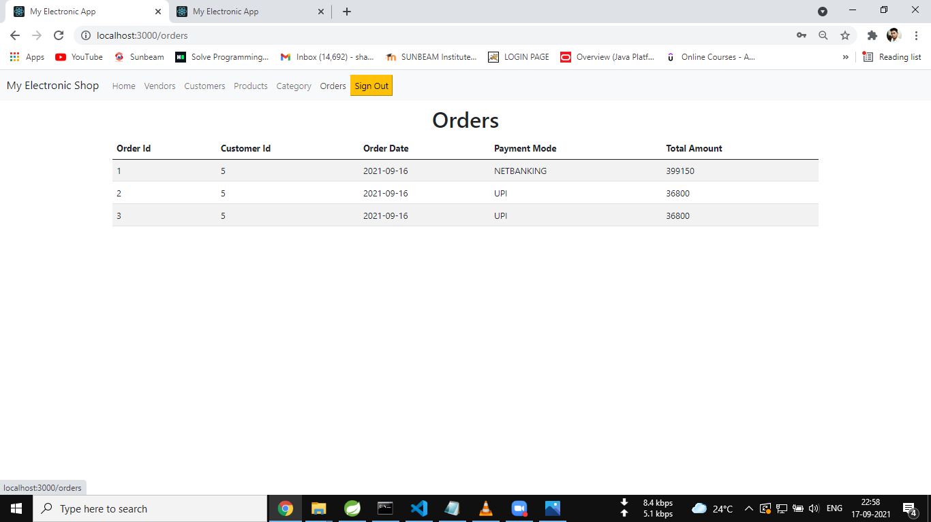

**REDIRECTED AFTER SIGNOUT:**

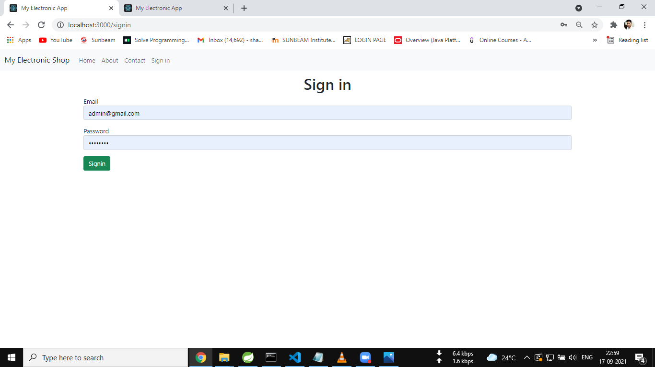

**VENDOR SIGNUP:**

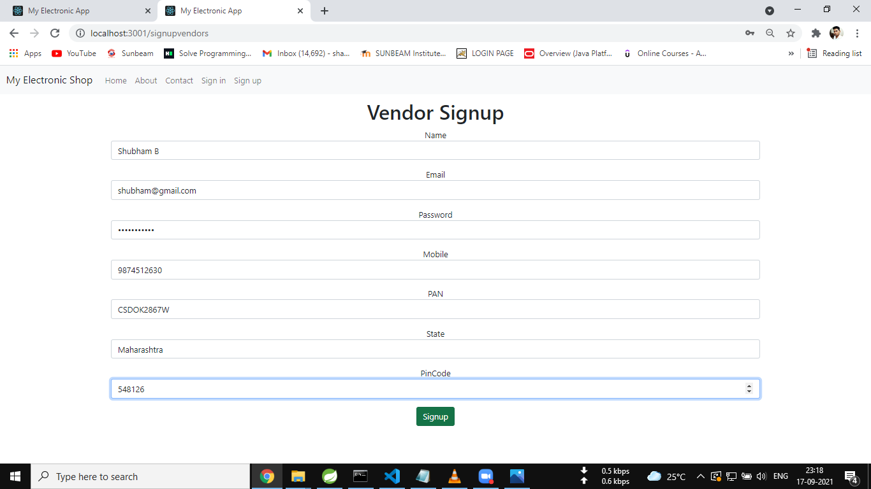

**VENDOR SIGNIN:**

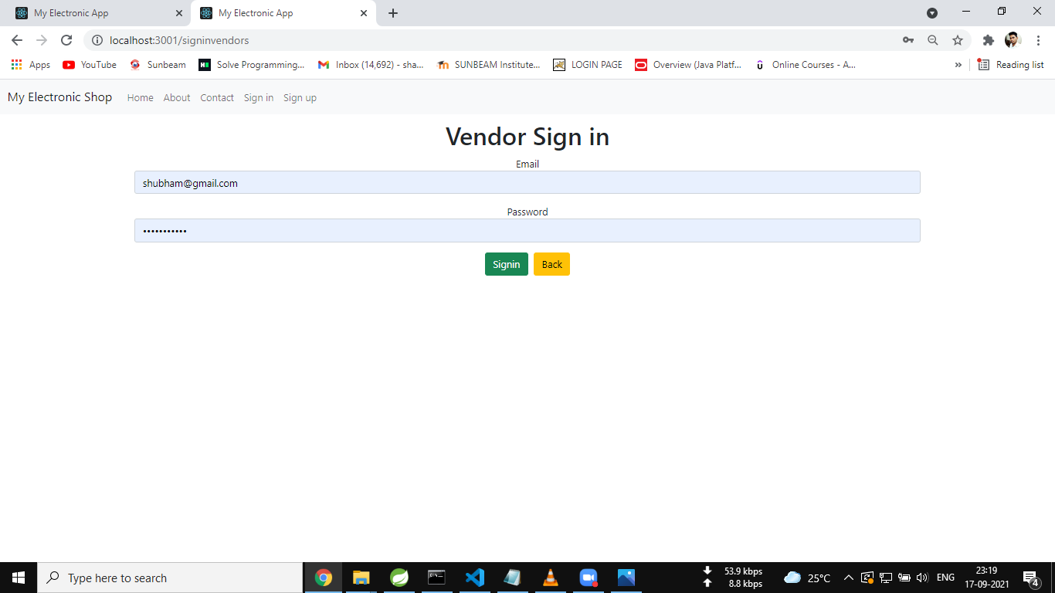

**UNAPPROVED VENDOR:**

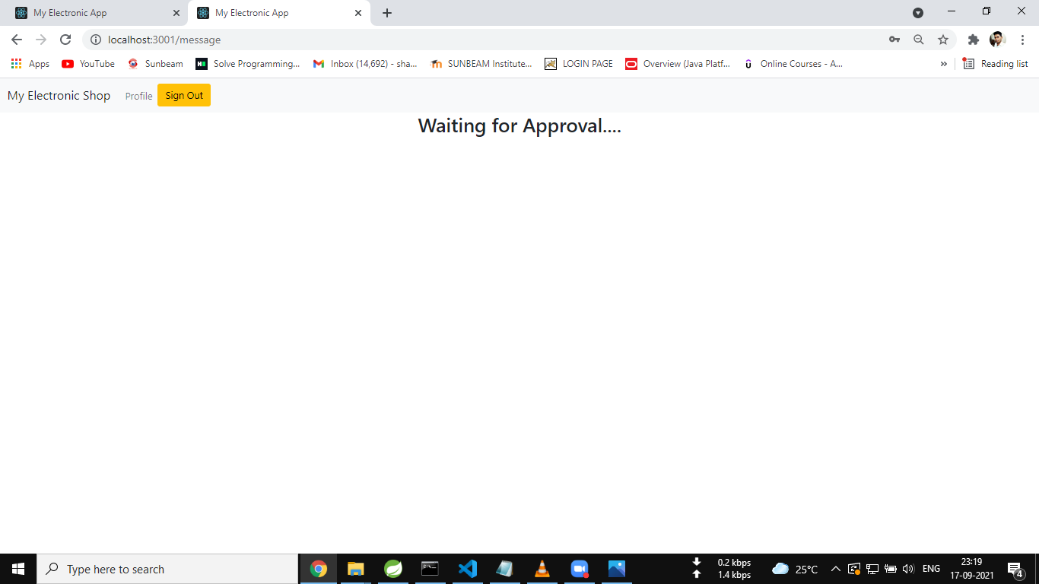

**HOME PAGE:**

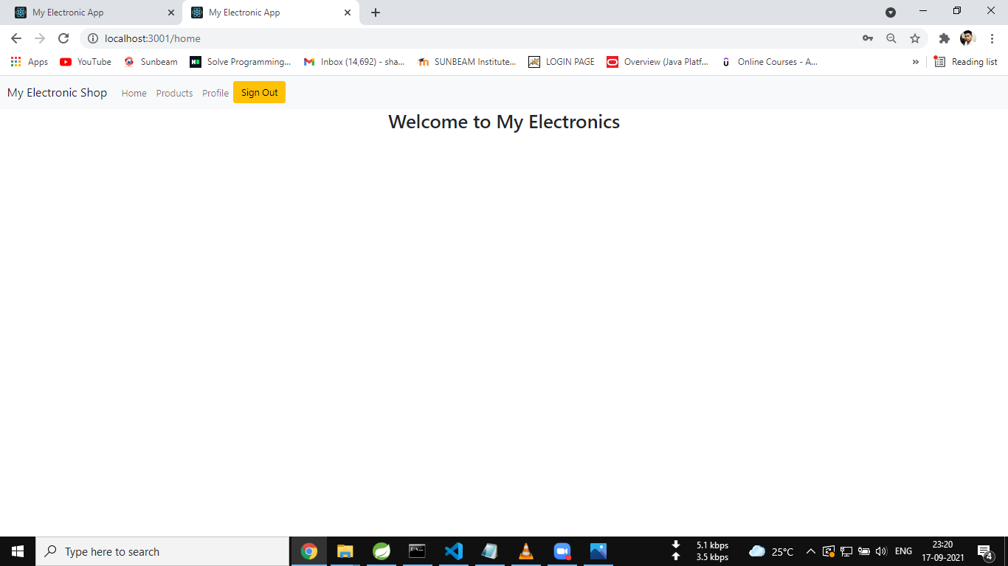

**ADDING PRODUCT:**

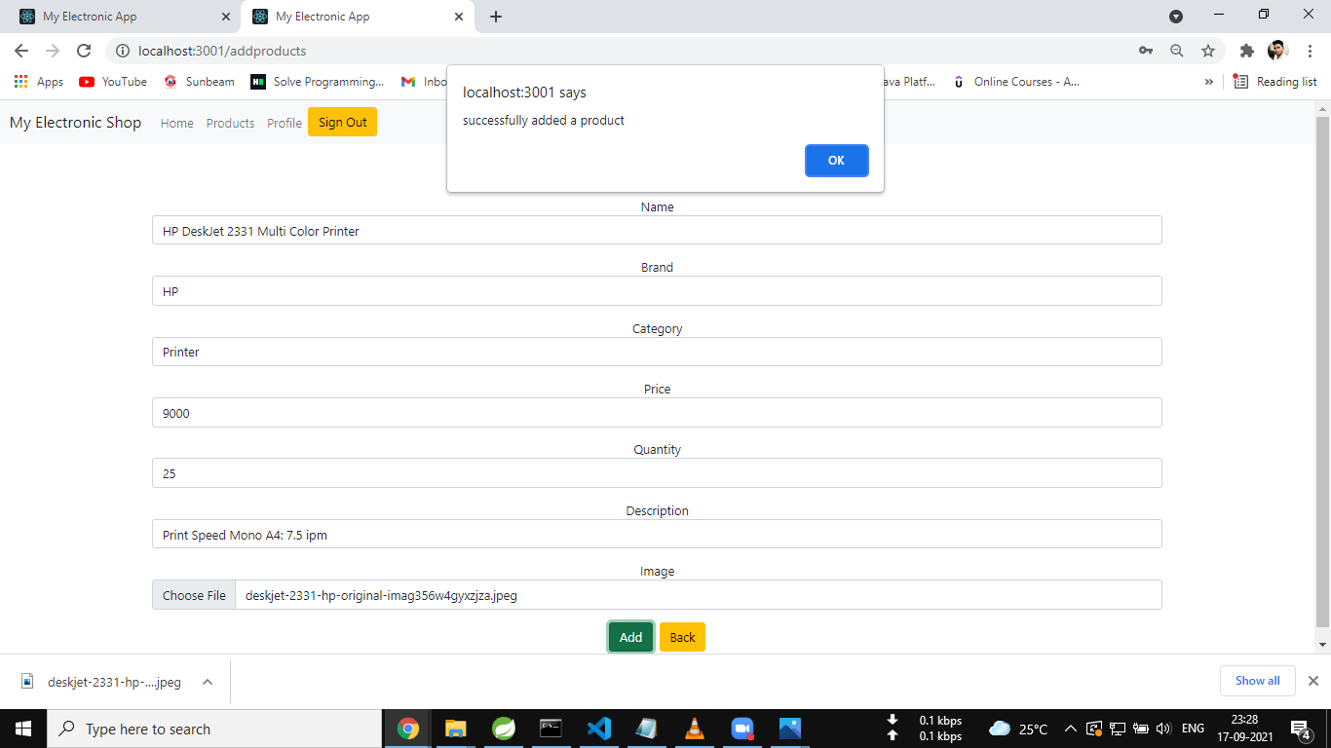

**ADDED PRODUCTS:**

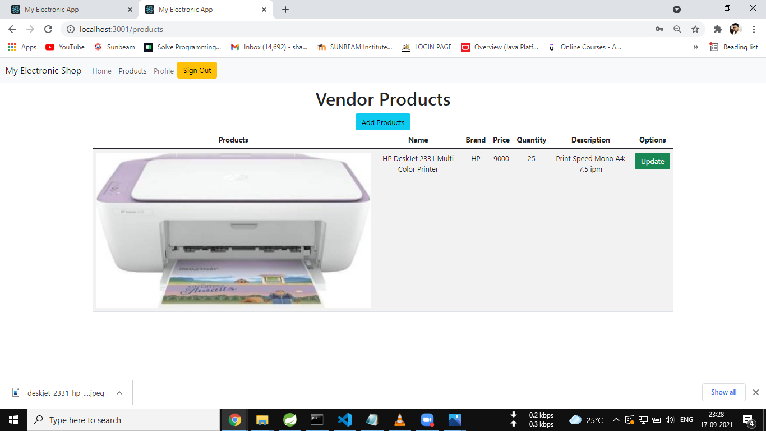

**UPDATE PRODUCT :**

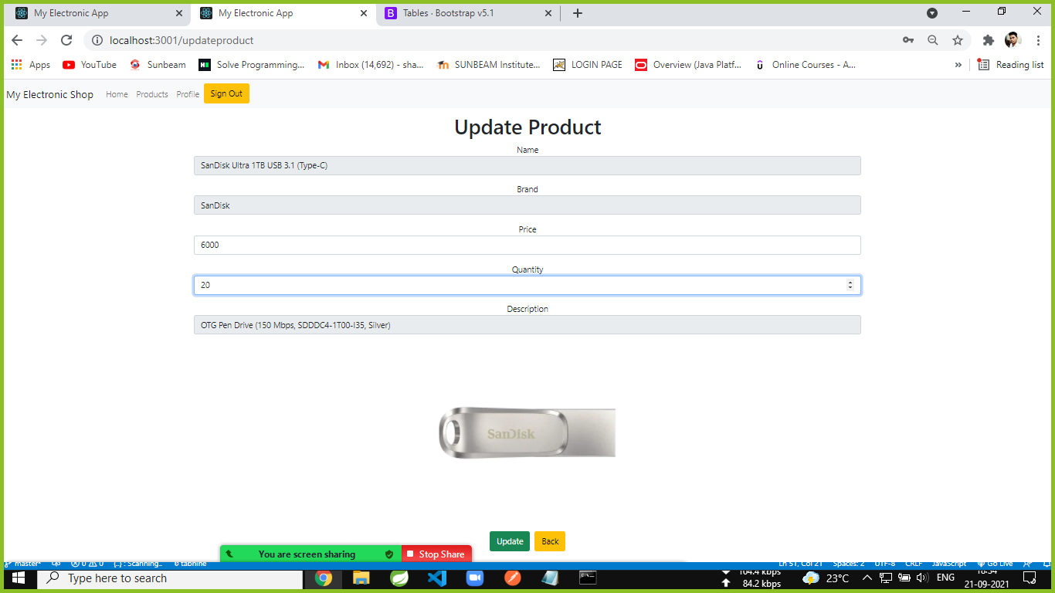

**UPDATE PROFILE:**

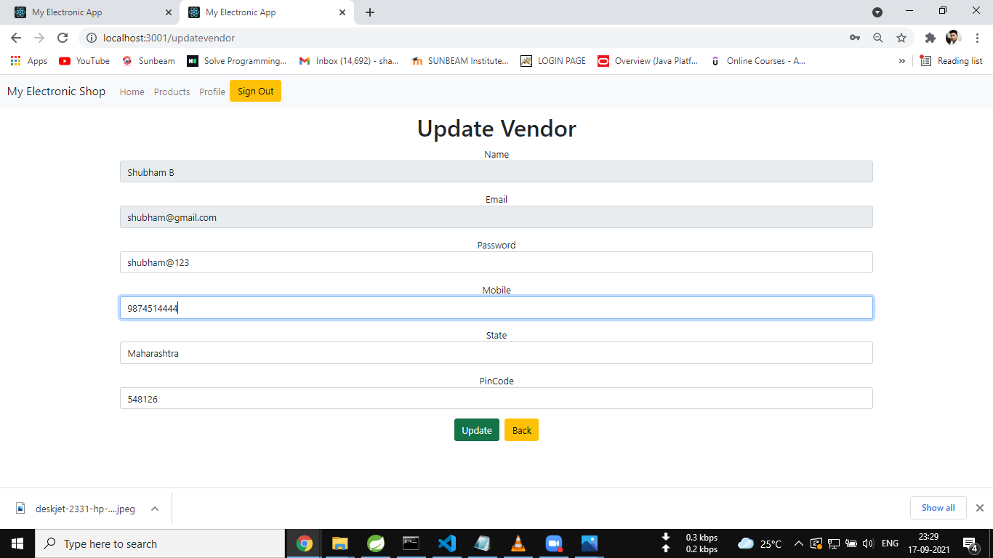

**REDIRECTED AFTER SIGNOUT:**

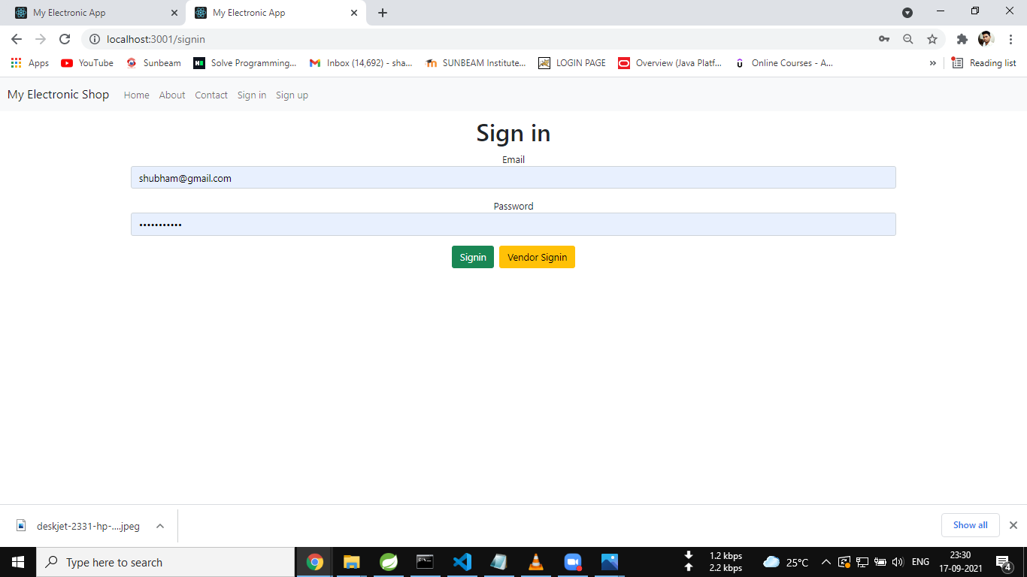

**CUSTOMER SIGNUP:**

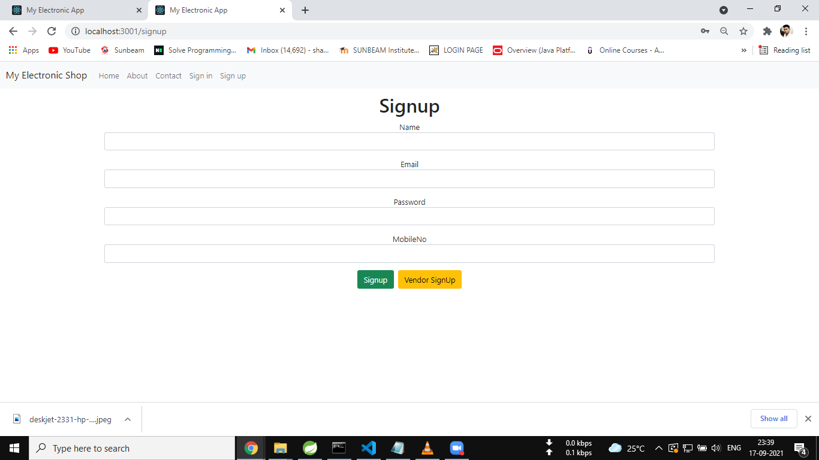

**CUSTOMER SIGNIN:**

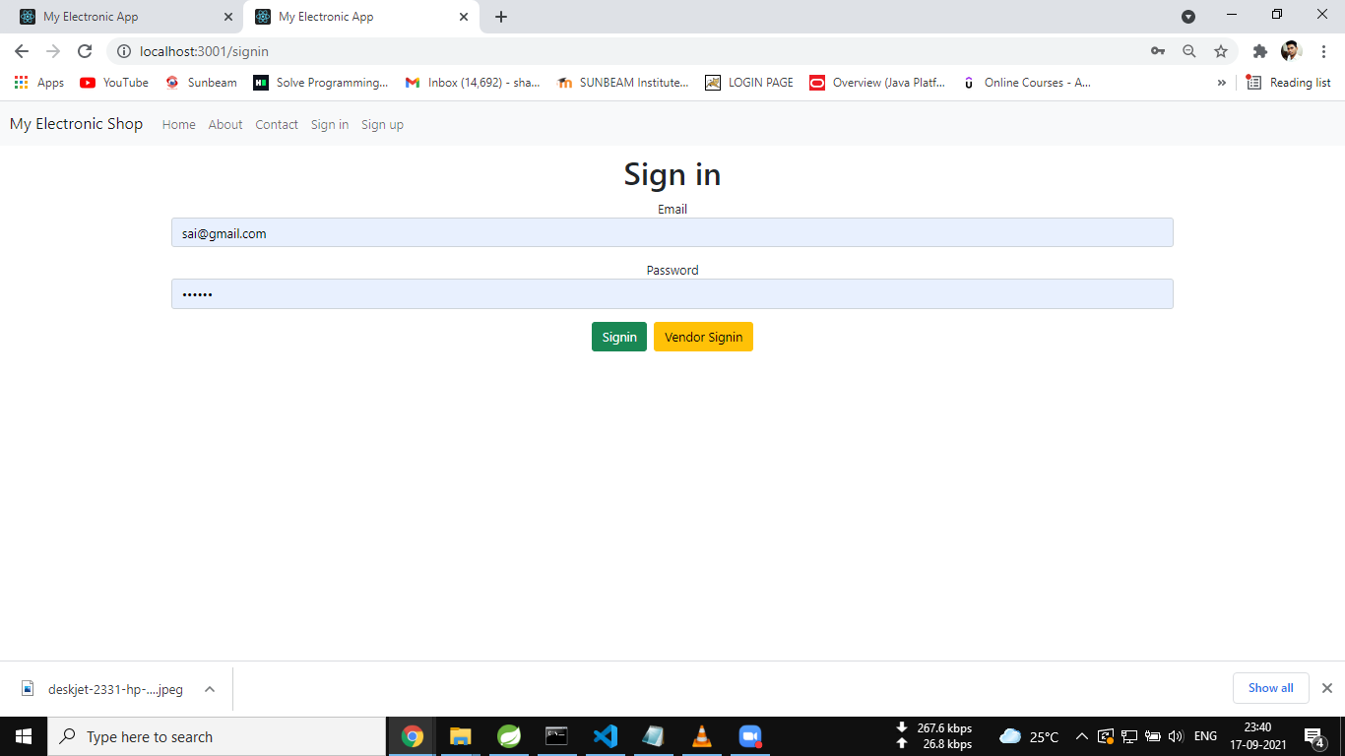

**HOMEPAGE:**

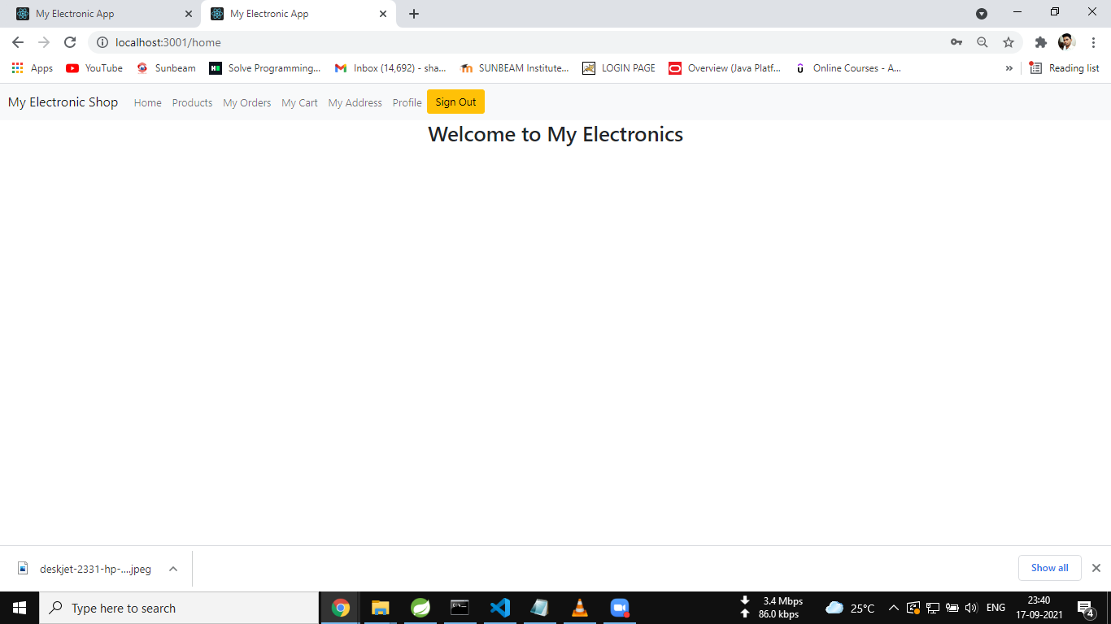

**ADD ADDRESS:**

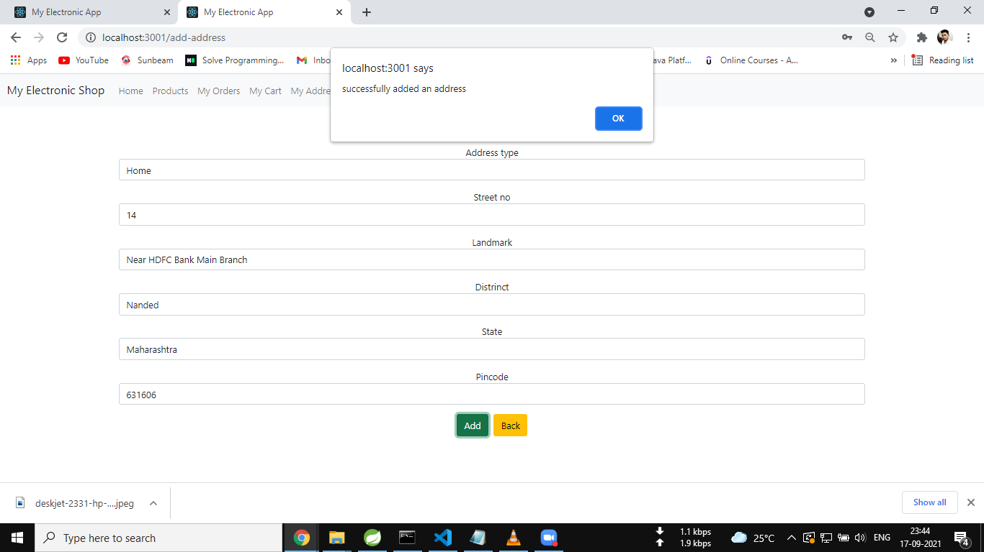

**ADDRESS DETAILS:**

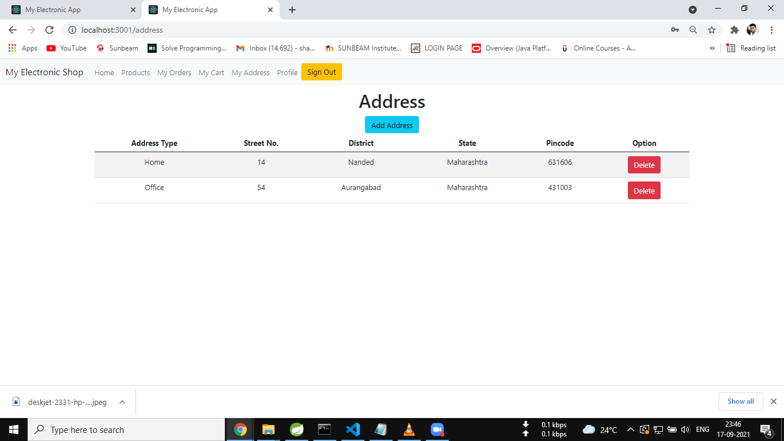

**PRODUCTS:**

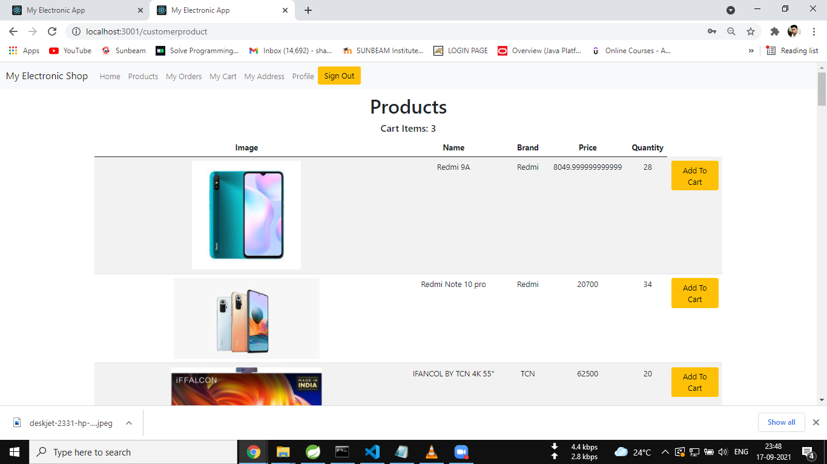

**MY CART:**

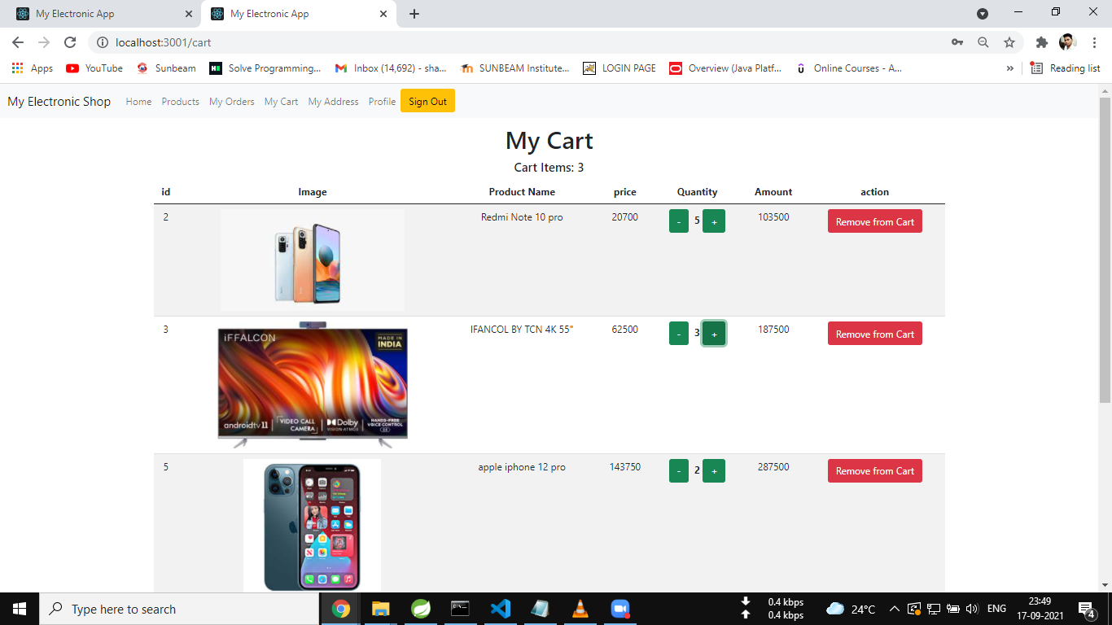

**SELECT ADDRESS:**

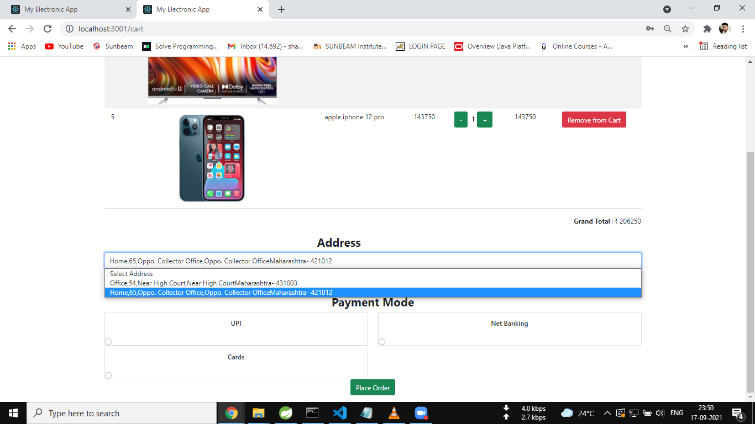

**SELECT PAYMENT MODE:**

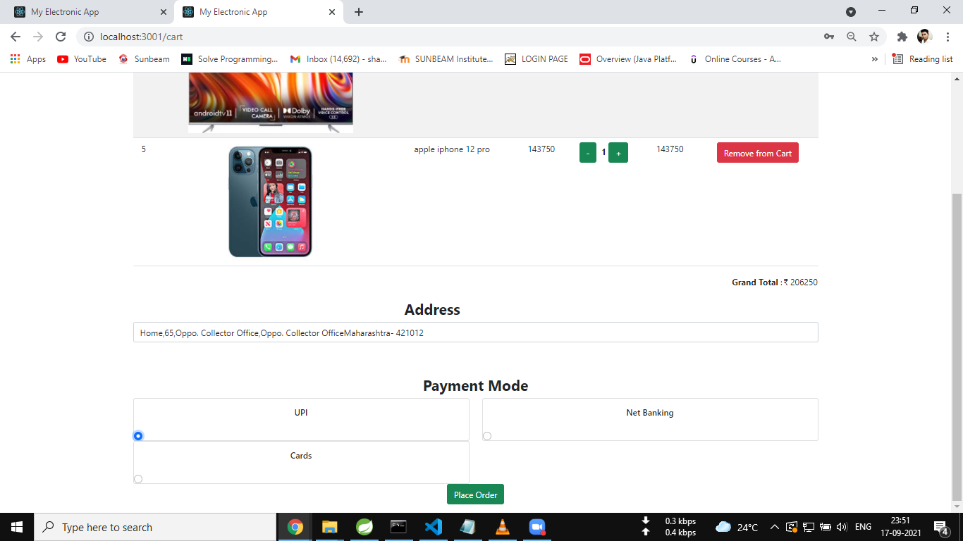

**ORDER HISTORY:**

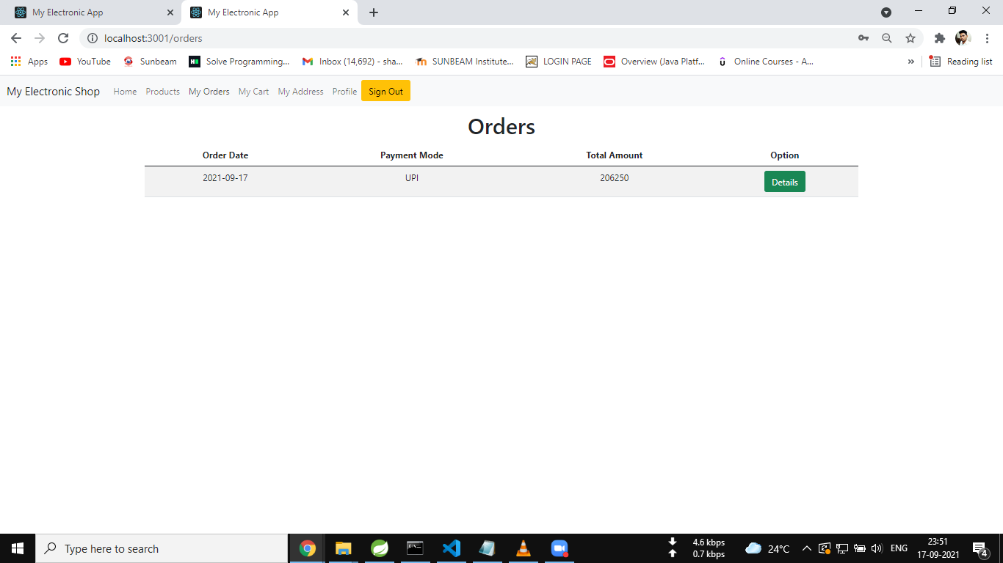

**UPDATE PROFILE:**

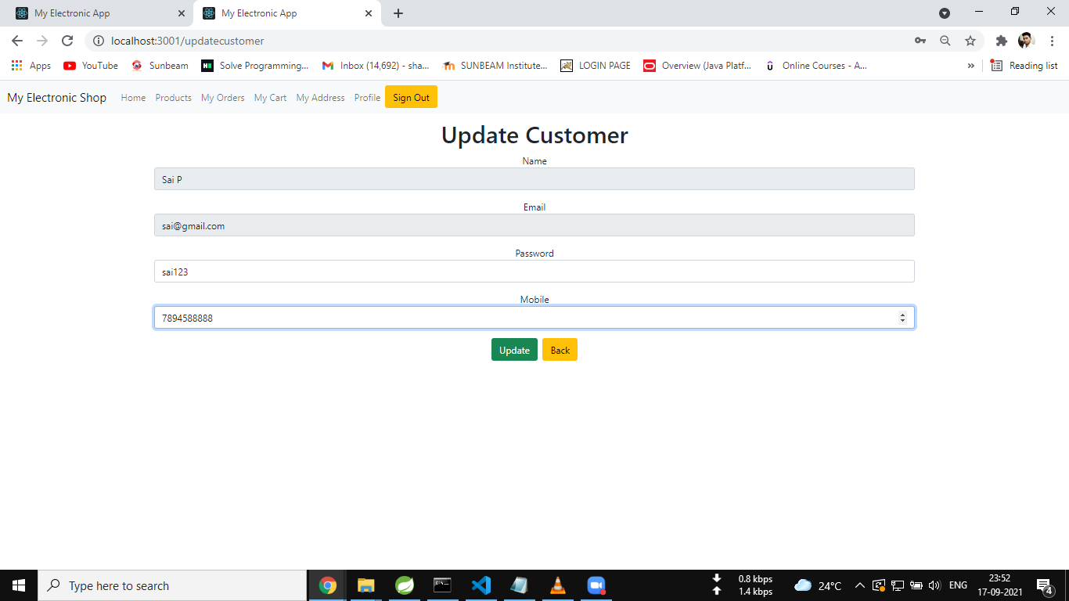

**REDIRECTED AFTER LOG OUT:**

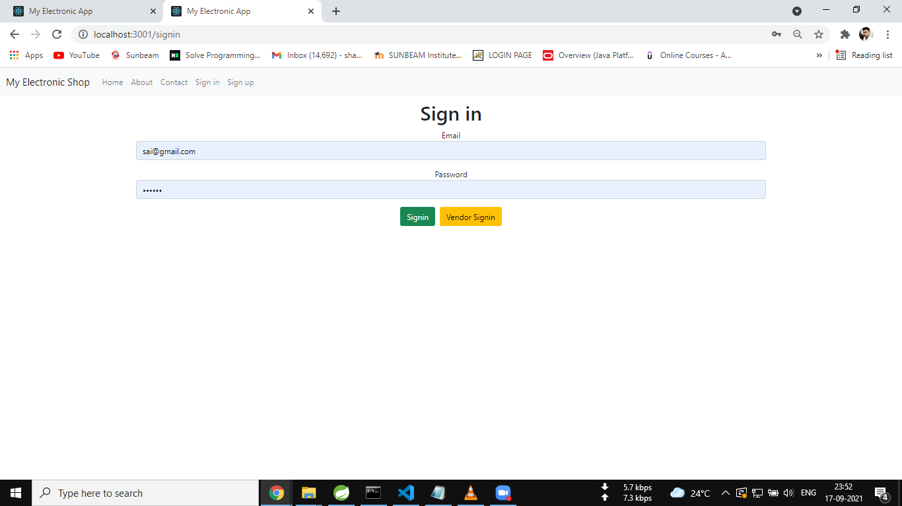

**7.REFERENCES:**

<http://www.google.com>

[http://](http://www.xml101.com:8081/xml/)www.croma.com

http://www.webdevelopersjournal.com/

http://www.tatacliq.com

http://www.w3.org

http://www.wikipedia.org

http://www.ubuy.co.in